University of Maryland

Final Portfolio

Sang Hwa Lee

INST 462 – 0101

Prof. Jennifer Golbeck

May 6, 2023

Introduction

I have acquired a diverse range of knowledge and skills related to visualization and the use of various tools for implementing visualizations throughout this course.

In terms of theory, I first studied the different types of data needed to construct visualizations, learning how various types of data, such as Items, Attributes, Links, Grid, and Position, are used. I also had the opportunity to learn about Validation, a process for evaluating the accuracy of analysis results. Additionally, I learned how to create visualizations using Marks and Channels and how to design visualizations in different shapes and styles. Moreover, I gained insight into color-related information, understanding the process of visual color perception and concepts like the Color Perception Pipeline. I also explored the rules and various themes for designing visualizations. Regarding Data Reduction, I learned why methods like Segmentation, Sampling, Clustering, Aggregation, and Dimensionality Reduction are used and how to apply them. Lastly, I studied how to judge visualizations and discern incorrectly used or deceptive graphs and visualizations (calling BS).

In the technical aspects of the course, I learned how to use Tableau to convert datasets into various charts and create desired visualizations. I also developed the ability to visualize graphs and interpret results using the Gephi tool by adjusting node and edge sizes, colors, and layouts. I learned how to visually represent words and select and filter words using Word Tree as well. Finally, I acquired fundamental but essential skills for constructing visualizations using HTML, JavaScript, and CSS files through D3.

Visualization

Visualization : Career Visualization

**Data Set**

This dataset contains values for GPA and cumulative GPA per semester. To obtain this information, I first used the Testudo website to gather data on my GPA for each semester of each year.

**Tool**

To create Visualization, I used an Excel tool.

**Process**

For this visualization, I utilized a bar chart. Using the values from the Excel file, I displayed the GPA for each semester and the cumulative GPA for the two variables, and to prevent analysis errors, I included numerical values for each bar.

**Insights**

The purpose of this process is to show my future employers how my GPA has evolved over time. This visualization allows them to see the changes in my GPA rather than just the average GPA. By specifying accurate x and y axes and including detailed numerical values in the bar chart, I can provide more reliable information.

<Visualization >

Visualization : Basic Visualization Design

**Data Set**

The dataset is based on historic hotel visitation patterns. The dataset was provided by the  
course professor.

**Tool**

The tools used were pencil, colored pencils, ruler, and paper because it was a hand drawn  
visualization.

**Process**

The visualization was generated using the various tools listed above to represent the dataset. I drew a ruler to map out the variables of the dataset, and then various sizes and colors of circles to represent the data.

**Insights**

Through this visualization, it can be seen that the data is somewhat consistent across the  
variables represented by the percentages. For example, the data for the "length of stay" was  
consistently small for all months. In contrast, the data in the categories "% businessmen" and  
"% direct reservations" were consistently large across all months.

< Visualization >

Visualization : Color

**Data Set**

The dataset contains detailed demographic information about political party affiliation in the US. It was provided by the professor as a part of course materials. It was originally generated on a CSV file.

**Tool**

The tool used to open the CSV file was Excel and the tool used to create an infographic with the data was Canva.

**Process**

The visualization was generated by using Canva. First, I narrowed down the data to show demographic information about each party and three demographic attributes – race, education, and income. Then, I used Canva to create my own template with a stacked chart to represent the data. I chose this type of visualization because I thought it showed all of the data in one big picture, which makes it easier for viewers to see and analyze. Additionally, I used different colors to represent each party, as you can see in the key at the bottom and on the chart itself, and I chose colors that are typically used for the parties to create less confusion. Lastly, I decided to add the percentages for each part of the stack bars to show the exact data.

**Insights**

What can we see with this visualization? With this visualization, you can see that the least amount of people is in the “other” parties overall. Also, when looking at education levels, there are consistent percentages across the board. Most people, regardless of education level, most people identify with the Independent Party, followed by the Democratic Party, the Republican Party, and then “other” parties. As for income level, when looking at just the Republican Party, the percentage and income level are positively correlating. Conversely, the other parties – Democratic, Independent, and “other” – show the opposite pattern with higher percentages correlating with lower incomes. I also noticed that the last part of the data,

< Visualization >

Visualization : Scatterplot Matrix

**Data Set**

The dataset contains information related to cars, including features such as Name, MPG, Cylinders, Displacement, Horsepower, Weight, Acceleration, Model, and Origin. This dataset was provided by the professor in the form of a CSV file specifically for this assignment.

**Tool**

To create visualizations using the CSV file, I used a program called Tableau.

**Process**

To create the visualization, first, import the CSV file provided by the professor into Tableau. Next, insert the variables to be compared into each sheet individually. For example, place the MPG variable in Rows and the Cylinders variable in Columns to create a scatter plot. Represent all possible combinations of variables in separate sheets. To show differences, include Origin in the color section of the Marks panel to distinguish between countries. We attempted to include Name in the detail section, but it would be difficult to identify precise values and could cause confusion when viewing the scatterplot matrix, so it was not added. In total, 21 sheets were completed. Afterward, create a dashboard to integrate the 21 sheets and construct the scatterplot matrix.

**Insights**

There are several insights that can be gained from this visualization. You can examine the relationships between car types, fuel efficiency, weight, the number of cylinders, engine displacement, and horsepower. Additionally, you can compare the characteristics of cars produced in different countries. You can also detect outliers and identify cars with unique performance or features.

< Visualization >

Result when Name is included in detail of Marks.

Visualization: Music Network Visualization

**Data Set**

The dataset was provided by the professor and was obtained from the website http://labs.polsys.net/playground/spotify/. This specific dataset is related to the network of the band Blackpink.

**Tool**

The tool used for this visualization is Gephi.

**Process**

This visualization was generated using several steps. First, the GDF file was obtained from the website https://labs.polsys.net/playground/spotify/. Then, it was opened using gephi. I used the layout “Force Atlas” to show the data. Next, I set the “Repulsion strength” to 10,000.0 to aid in easier visualization the data because there were about 462 nodes, which were many nodes to look through. Then, I ran the modularity and network diameter statistics. I changed the “Color” for the “genres” option under the “Partition” and used the various colors. Finally, I changed the “Edges” color from gray to black to make it easier to see.

**Insights**

The artist group I searched for is Blackpink. From the visualization, you can see how the colors and sizes represent different parts of Blackpink’s network. Basically, I organized the size of each node according to its popularity. As the size of a node increases, it is composed of more popular groups or people. Next, the colors of the nodes were configured so that the color could be different depending on the genre. Therefore, nodes are color-coded according to each genre and are displayed.

The most important node is the Blackpink node. The main nodes involved are those with labels such as Mamamoo, (G)I-DLE, TWICE, Red Velvet, and Momoland. The reason why these nodes are connected to BLACKPINK's nodes is because of the color of the nodes. Being designated as blue means that it is set as a girl group of K-pop. Of course, there are cases where other disconnected nodes have blue, but a girl group with a blue node that connects Blackpink and the edge may have been active at the same time, have performed together, or can appear through interaction or communication between each fandom.

Also, the nodes marked in purple and connected to the Blackpink node appear to be individual members included in various K-pop girl groups. Therefore, in the case of Jennie and Rose are members of Blackpink and are connected to the Blackpink node and edges. Also, when analyzing this visualization, the position between girl groups and boy groups in K-pop seems to be very far away. It can be judged that male girl groups and female girl groups do not often have much relation to each other, whether it is through connected events, people, or fandoms.

Finally, the people with red nodes are solo artists. Therefore, it is seen that they are close to singers who do a lot of solo activities together and are connected by edges.

< Visualization >

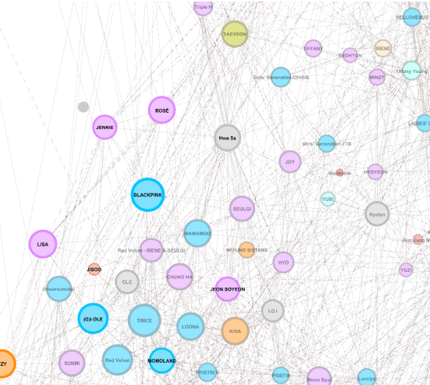

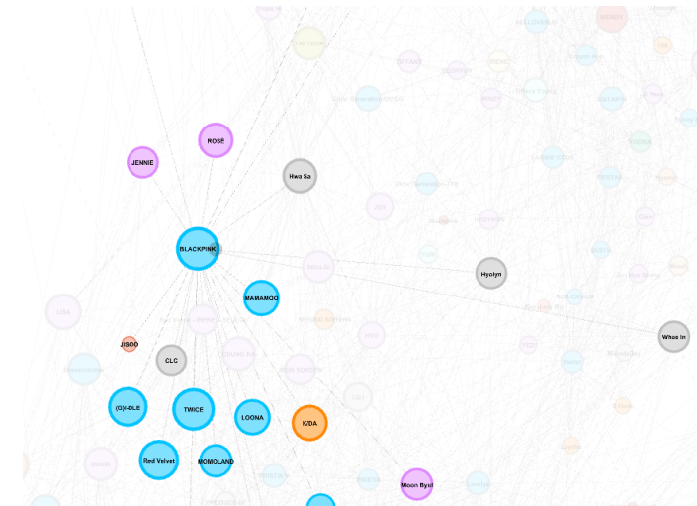

Visualization: Word Tree

**Data Set**

I used a poem to analyze the tool using word tree. The poem is "The Raven" by Edgar Allan Poe. This poem published in 1845, is one of Poe's most famous works. I found this poem by searching for poetry with many repeated phrases.

**Tool**

To conduct this analysis, I used a visualization tool called Jason Davies' Word Tree that professor provided.

**Process**

First, I needed to input the entire text of the poem "The Raven" into the tool. I copied the full poem and input it into the Paste Text area, then generated the word tree. I created the word tree using the word "nevermore," which is consistently repeated throughout the poem.

**The Raven**

Once upon a midnight dreary, while I pondered, weak and weary,

Over many a quaint and curious volume of forgotten lore—

While I nodded, nearly napping, suddenly there came a tapping,

As of some one gently rapping, rapping at my chamber door.

“’Tis some visitor,” I muttered, “tapping at my chamber door—

Only this and nothing more.”

Ah, distinctly I remember it was in the bleak December;

And each separate dying ember wrought its ghost upon the floor.

Eagerly I wished the morrow;—vainly I had sought to borrow

From my books surcease of sorrow—sorrow for the lost Lenore—

For the rare and radiant maiden whom the angels name Lenore—

Nameless here for evermore.

And the silken, sad, uncertain rustling of each purple curtain

Thrilled me—filled me with fantastic terrors never felt before;

So that now, to still the beating of my heart, I stood repeating

“’Tis some visitor entreating entrance at my chamber door—

Some late visitor entreating entrance at my chamber door;—

This it is and nothing more.”

Presently my soul grew stronger; hesitating then no longer,

“Sir,” said I, “or Madam, truly your forgiveness I implore;

But the fact is I was napping, and so gently you came rapping,

And so faintly you came tapping, tapping at my chamber door,

That I scarce was sure I heard you”—here I opened wide the door;—

Darkness there and nothing more.

Deep into that darkness peering, long I stood there wondering, fearing,

Doubting, dreaming dreams no mortal ever dared to dream before;

But the silence was unbroken, and the stillness gave no token,

And the only word there spoken was the whispered word, “Lenore?”

This I whispered, and an echo murmured back the word, “Lenore!”—

Merely this and nothing more.

Back into the chamber turning, all my soul within me burning,

Soon again I heard a tapping somewhat louder than before.

“Surely,” said I, “surely that is something at my window lattice;

Let me see, then, what thereat is, and this mystery explore—

Let my heart be still a moment and this mystery explore;—

’Tis the wind and nothing more!”

Open here I flung the shutter, when, with many a flirt and flutter,

In there stepped a stately Raven of the saintly days of yore;

Not the least obeisance made he; not a minute stopped or stayed he;

But, with mien of lord or lady, perched above my chamber door—

Perched upon a bust of Pallas just above my chamber door—

Perched, and sat, and nothing more.

Then this ebony bird beguiling my sad fancy into smiling,

By the grave and stern decorum of the countenance it wore,

“Though thy crest be shorn and shaven, thou,” I said, “art sure no craven,

Ghastly grim and ancient Raven wandering from the Nightly shore—

Tell me what thy lordly name is on the Night’s Plutonian shore!”

Quoth the Raven “Nevermore.”

Much I marvelled this ungainly fowl to hear discourse so plainly,

Though its answer little meaning—little relevancy bore;

For we cannot help agreeing that no living human being

Ever yet was blessed with seeing bird above his chamber door—

Bird or beast upon the sculptured bust above his chamber door,

With such name as “Nevermore.”

But the Raven, sitting lonely on the placid bust, spoke only

That one word, as if his soul in that one word he did outpour.

Nothing farther then he uttered—not a feather then he fluttered—

Till I scarcely more than muttered “Other friends have flown before—

On the morrow he will leave me, as my Hopes have flown before.”

Then the bird said “Nevermore.”

Startled at the stillness broken by reply so aptly spoken,

“Doubtless,” said I, “what it utters is its only stock and store

Caught from some unhappy master whom unmerciful Disaster

Followed fast and followed faster till his songs one burden bore—

Till the dirges of his Hope that melancholy burden bore

Of ‘Never—nevermore’.”

But the Raven still beguiling all my fancy into smiling,

Straight I wheeled a cushioned seat in front of bird, and bust and door;

Then, upon the velvet sinking, I betook myself to linking

Fancy unto fancy, thinking what this ominous bird of yore—

What this grim, ungainly, ghastly, gaunt, and ominous bird of yore

Meant in croaking “Nevermore.”

This I sat engaged in guessing, but no syllable expressing

To the fowl whose fiery eyes now burned into my bosom’s core;

This and more I sat divining, with my head at ease reclining

On the cushion’s velvet lining that the lamp-light gloated o’er,

But whose velvet-violet lining with the lamp-light gloating o’er,

She shall press, ah, nevermore!

Then, methought, the air grew denser, perfumed from an unseen censer

Swung by Seraphim whose foot-falls tinkled on the tufted floor.

“Wretch,” I cried, “thy God hath lent thee—by these angels he hath sent thee

Respite—respite and nepenthe from thy memories of Lenore;

Quaff, oh quaff this kind nepenthe and forget this lost Lenore!”

Quoth the Raven “Nevermore.”

“Prophet!” said I, “thing of evil!—prophet still, if bird or devil!—

Whether Tempter sent, or whether tempest tossed thee here ashore,

Desolate yet all undaunted, on this desert land enchanted—

On this home by Horror haunted—tell me truly, I implore—

Is there—is there balm in Gilead?—tell me—tell me, I implore!”

Quoth the Raven “Nevermore.”

“Prophet!” said I, “thing of evil!—prophet still, if bird or devil!

By that Heaven that bends above us—by that God we both adore—

Tell this soul with sorrow laden if, within the distant Aidenn,

It shall clasp a sainted maiden whom the angels name Lenore—

Clasp a rare and radiant maiden whom the angels name Lenore.”

Quoth the Raven “Nevermore.”

“Be that word our sign of parting, bird or fiend!” I shrieked, upstarting—

“Get thee back into the tempest and the Night’s Plutonian shore!

Leave no black plume as a token of that lie thy soul hath spoken!

Leave my loneliness unbroken!—quit the bust above my door!

Take thy beak from out my heart, and take thy form from off my door!”

Quoth the Raven “Nevermore.”

And the Raven, never flitting, still is sitting, still is sitting

On the pallid bust of Pallas just above my chamber door;

And his eyes have all the seeming of a demon’s that is dreaming,

And the lamp-light o’er him streaming throws his shadow on the floor;

And my soul from out that shadow that lies floating on the floor

Shall be lifted—nevermore!

**Insights**

1. Helpful to gain more insight.

- This tool can help you quickly understand in what context the word "nevermore" is used throughout the poem. This can help us understand how a word is related to another word or phrase. Therefore, it can provide insight into the overall theme and structure of the poem.

2. A weakness of this tool

- This tool can simplify the structure of the text into a tree form, making the overall flow or structure of the poem difficult to fully understand. Therefore, it can provide information in a state that deviates from the original context of the poem, so it can represent a limited form for catching the subtle nuances that appear in the poem.

**Works Cited**

Poe, Edgar Allan. “The Raven by Edgar Allan Poe.” Poetry Foundation, Poetry Foundation, <https://www.poetryfoundation.org/poems/48860/the-raven>.

< Visualization >

Analysis

Analysis: Novel Visualization

**Data Set**

The dataset used for the "Atmospheric carbon dioxide concentration" spiral visualization is the record of carbon dioxide measurements taken at the Mauna Loa Observatory in Hawaii since 1958. This data is publicly available and is one of the longest continuous records of carbon dioxide concentration in the atmosphere.

**Tool**

The tool used to create this visualization is not specified on the website.

**Analysis**

The visualization provides insights into the trends and patterns of carbon dioxide concentration in the atmosphere over time. The spiral graph allows viewers to see the steady increase in carbon dioxide concentration since 1958, with a small seasonal cycle visible in the graph. This visualization helps to illustrate the alarming rise in carbon dioxide levels and the urgent need for action to mitigate the effects of climate change.

By visualizing the data in this way, the viewer can also see how the concentration of carbon dioxide changes seasonally, with higher concentrations in the winter months and lower concentrations in the summer. This can help to understand how different factors affect the concentration of carbon dioxide in the atmosphere and the importance of taking action to reduce greenhouse gas emissions.

Overall, this visualization serves as a powerful reminder of the ongoing impact of human activities on the environment and the urgent need for action to address climate change.

<https://www.climate-lab-book.ac.uk/spirals>

< Visualization >

Analysis: Novel Visualization

**Data Set**

This visualization, called Wind Map, uses a dataset that represents the movement of air to create a visual representation of it.

**Tool**

The tool used to create this visualization is not specified at this website(<http://hint.fm/projects/wind/>).

**Analysis**

Through this visualization, one can gain insights into the weather patterns of a region by observing the continuously changing wind movements. Additionally, one can understand how various terrains and geographical features affect wind patterns. However, without knowing the specifics of the dataset used, it is unclear whether the wind movements are accurately analyzed in real-time.

< Visualization >

Analysis: Novel Visualization

**Data Set**

The dataset used in this spiral visualization was created by Jay Alder from the USGS, based on high-emissions future projections.

**Tool**

The website does not mention what tools were used to create this visualization.

**Analysis**

Through this visualization, one can visually understand how future climate change is expected to occur. The tornado-shaped graph helps to understand how temperature changes over time. Additionally, this visualization can be useful for intuitively understanding the results of climate modeling and considering possible responses to future climate change. However, if the specific dataset used to create this visualization is unknown, relying on it may be problematic, potentially raising concerns about its reliability.

<https://www.climate-lab-book.ac.uk/spirals>

< Visualization >

Analysis : Good Visualization

**Data Set**

This dataset was found by searching on the Internet. This data visualization is in which some famous artists in hip-hop compare the number of unique words they use. Analyze the use of unique words by random artists. Since then, it can be analyzed that hip-hop artists have used a lot of unique words. Since then, the unique word usage of hip-hop artists is analyzed and represented by data visualization.

**Tool**

To represent this visualization, they used token analysis using bar charts and Python tools.

**Analysis**

While analyzing this data visualization, I was wondering how to count similar words. In this dataset, I found that similar words were put together as one. Also, I could observe that hip-hop cannot be fully defined because there are many compound words that are difficult to describe. It also showed that the number of unique words decreased when it deviated from the song of hip-hop structure.

< Visualization >

Analysis : Tasks

**Data Set**

The dataset are in the two thesauri – [www.visualthesaurus.com](http://www.visualthesaurus.com) and [www.thesaurus.com](http://www.thesaurus.com). These are websites that act as a thesaurus. This dataset was provided by the professor for this course assignment. The dataset of synonyms are generated by these websites.

**Tool**

The tool used for this assignment were the two thesauri - [www.visualthesaurus.com](http://www.visualthesaurus.com) and [www.thesaurus.com](http://www.thesaurus.com).

**Analysis**

The following questions were provided by the course assignment:

1. what is your task?

2. what is your measure and why?

3. which tool does better? why do you think that is?

4. which tool do you like better? is that in line with the performance on the task?

5. what did you learn from this?

The analysis was based on tasks. For this lab, a task that someone would want to do with a thesaurus would be to study vocabulary for a TOEFL Exam. A person may want to expand his or her vocabulary so that a broader range of words may be used for the Writing and Speaking portions of the exam. This way, the person may explain more clearly in detail rather than repeat him or herself.

The measure for this task could be a quantitative data measurement of how many synonyms the thesaurus provides for a certain vocabulary word. This would be because more synonyms provided by the thesaurus gives the person more data to input for his or her vocabulary.

The second tool, [www.thesaurus.com](http://www.thesaurus.com), does better because it provides more synonyms for the inputted vocabulary word. For example, when searching ‘ephemeral,’ this tool gave 15 synonyms whereas the other tool, [www.visualthesaurus.com](http://www.visualthesaurus.com), provided only 6 synonyms.

I personally like the [www.thesaurus.com](http://www.thesaurus.com) tool better because it provides more synonyms for the task, which is especially important for people studying vocabulary for the TOEFL test. It even includes antonyms, words related to the searched word, and various shades of color to show how close the synonyms may be to the vocabulary word that was searched. It is true that the [www.visualthesaurus.com](http://www.visualthesaurus.com) tool provides the parts of speech, and this may be useful for someone who needs that data, but for a person wanting to simply know more vocabulary, [www.thesaurus.com](http://www.thesaurus.com) would be better. Therefore, my opinion is in line with the performance on the task.

From this assignment, I learned by seeing practical ways in which visualized data can be measured quantitatively and qualitatively. It was very helpful to make my own task and then see how these two websites provide different kinds of data. I chose to measure data quantitatively, using the number of synonyms provided. However, I also got to see how qualitative data can be collected from the same websites – using color shades and visual maps.

<Visualization>

Analysis : Channels

**Data Set**

This dataset visualized income and life expectancy across continents and countries in 2021. I was able to get it through the link provided by the professor, and I can see that it generated using the Gapminder tool.

**Tool**

A tool called Gapminder was used to create this data visualization.

**Analysis**

1. There are at least 4 channels used here. List them.

- The visualization has color, shape, size, position.

2. Find an existing visualization online that uses 5 or more channels. List each channel used and what it represents. Are all these channels effective or are some harder to see and get insights from?

- This data visualization showed differences in happiness and ecological footprints in each country. Color, shape, size, position, and texture were used in this data visualization.

- Color shows the difference in the ecological footprint of each country. Shapes are circles that represent a person's face and can help represent happiness. Size represents a difference in population. Position is distributed differently depending on the location of each country on the map. Texture is used to show differences in happiness in each country.

- All these channels have their own roles. It is organized to make data visualization easier for viewers to recognize, and the role of each channel is well used, so it can be considered effective.

<Visualization>

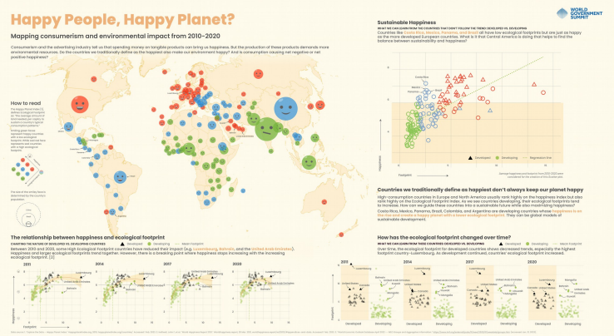

<https://informationisbeautiful.net/visualizations/world-dataviz-prize-2023-poster-longlist/>

Analysis : Visualization Evaluation

**Data Set**

The dataset is a database of all orbiting satellites, and this assignment is based on two interactive visualizations. It is provided by the Union of Concerned Scientists.

**Tool**

The tools used for this analysis are the dataset, a heuristic evaluation, and a question-based evaluation of two interactive visualizations.

**Analysis**

For the first part of the assignment, a heuristic evaluation was used for the analysis.

QZ Interactive Graphic of Every Active Satellite

1.This visualization makes important information visually salient.

3 – This visualization makes some important information visually salient. This information includes the satellite’s country, purpose, age, primary user, and launch vehicle. However, it requires some exploration on the user’s part to figure out how to find the information.

2. This visualization uses visual components appropriately.

2 – This visualization effectively used visual components such as position, size, shape which are the examples of the channels. However, not all countries were separated by their own colors, so it is not represented the color-related parts in detail.

3. This visualization successfully presents multiple relevant facts into a single visual pattern.

5 – This visualization successfully presents multiple relevant facts into a single pattern. It represents all data with circles of various colors and sizes onto the chart.

4. Assign this visualization an overall score from 1 (low) to 5 (high) that reflects its overall effectiveness and design quality.

- I would give this visualization an overall score of a 3.3 because the scores of each number were added and calculated. Overall, it shows various visual components in single pattern. However, it takes a lot of time for users to get used to visualization.

For the second part of the assignment, a question-based evaluation was used for the analysis.

Satellizer Visualizing 11 Years of Satellite Launches

1.This visualization makes important information visually salient.

(4Point) - This visualization makes some important information visually salient. This information includes the satellite’s country, the amount and time launched by country, the purpose and the weight. However, important information is linked various visualizations.

2. This visualization uses visual components appropriately.

(5Point) - This visualization effectively used visual components such as position, size, shape, color which are the examples of the channels. Regarding color, since it is limited to represent all satellites by country, categorizing colors according to purpose allows users to easily access visualizations.

3. This visualization successfully presents multiple relevant facts into a single visual pattern.

(2Point) - This visualization presents multiple relevant facts using multiple patterns. It represents the data using different visualizations in addition to the different colored circles, such as bar graphs, table, and map.

4. Assign this visualization an overall score from 1 (low) to 5 (high) that reflects its overall effectiveness and design quality.

I would give this visualization an overall score of a 3.6 because the scores of each number were added and calculated. Overall, it shows various visual components in many patterns. However, it provided many patterns, therefore, it can interfere about the user's obtaining information processing.

If possible, provide the answer, a short description of how that was visually represented, and any interaction that supported finding the answer (e.g. if I click on this thing, is shows me this other information). Include screen shots if appropriate. If you cannot answer a question with the visualization, that is ok. Note that and explain why the visualization fails there.

1. How many satellites does Russia have in orbit, and what are they used for? Russia has 112 satellites in orbit. 69 are used for military purposes, 57 for commercial, 24 for government, and 3 for civil uses. This was represented by the bar graph on the right sides of the Satellizer visualization. I had to click on Russia on the map in order for the bar graphs to show this information.

*Pic(1)*

2. Among all countries together, how many satellites are used for military purposes versus commercial purposes (give an approximate ratio or percentage if you can't find actual numbers)?

Among all of the countries, 260 are used for military purposes and 459 are used for commercial purposes. This was again represented by the bar graph on the right side of the Satellizer visualization. I had to click on “Civil” and “Government” on the top of the page to deselect these options to see the data for commercial and military satellites.

*Pic(2)*

3. Which countries have earth-observing satellites?

Based on the QZ visualization, it looks like the US, Russia, China, Japan, India, European countries, and multinational and other satellites all have earth-observing satellites. I think this data was represented by the circles that are in the “Low earth orbit” section of the visualization. This is because I clicked on “purpose” on the top menu to find that all of the satellites in “Low earth orbit” seemed to have earth-observing purposes. Then, I clicked on “country” to find out which countries had satellites in the “Low earth orbit.” However, this data is only an approximation because this visualization, nor the other visualization from Satellizer, does not explicitly state which satellites are earth-observing.

*Pic(3)*

4. When was the oldest working satellite launched?

The oldest working satellite was launched in 1974. This was represented by the gray colored circle on the QZ visualization. To find this information, I clicked the “age” category at the top, saw that pre-1995 satellites were gray, looked through the visualization for any gray circles, and then placed my cursor over the gray ones to compare their ages.

5. At what altitudes do most satellites orbit?

Based on the QZ visualization, it looks like most satellites orbit in the “low earth orbit” between 300 and 2,000 km above earth. This is another approximation because it looks like most satellites are in between these altitudes when compared to the others. However, it could be argued that there may be more satellites in the altitudes of the “medium earth orbit” but it cannot be seen very well as the circles overlap each other. I found this information by estimating how many circles there may be based on the different sections of the atmosphere in the QZ visualization.

*Pic(4)*

6. What activities are most satellites involved with?

Most satellites are involved with commercial uses. This information can be found on the right side of the Satellizer visualization. I deselected all options to show the uses of all satellites from all countries and it shows that commercial uses have the highest number.

*Pic(5)*

<Visualization>

Pic (1)

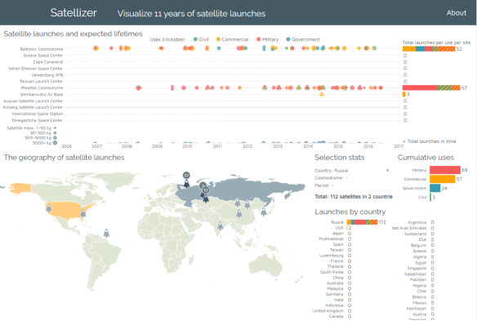

Pic(2)

Pic(3) -1

Pic(3) – 2

Pic(3) – 3

Pic(4)

Pic(5)

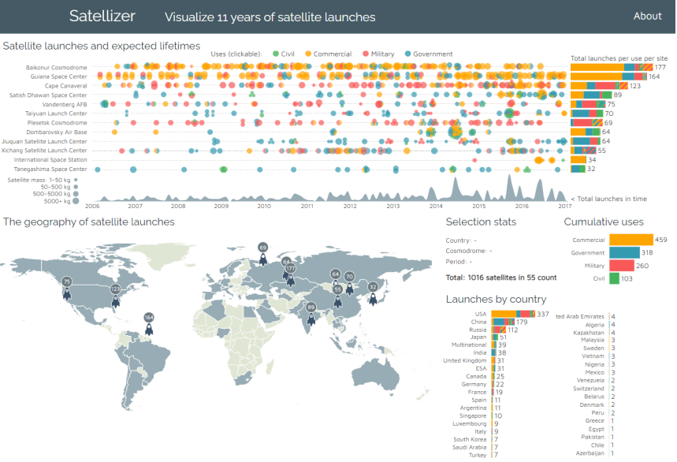

Analysis : Calling BS

**Data Set**

While searching the internet for misleading visualizations, I came across an interesting graph in a CNBC article. This dataset compares the stock price trends of Tesla and Netflix, and the graph included in the article serves as an example of a visualization that could cause confusion.

**Tool**

The only tool I used to find the graph was an internet browser. No specific information was provided about the tools used to create visualization within the article.

**Analysis**

Several issues can be found in the graph provided in the article. Firstly, the two lines in the graph overlap, making it difficult to determine their similarity. Also, there is no clear indication of what the X and Y axes represent. Additionally, the labels on the Y-axis make it difficult to perceive the difference between the left(blue) and the right(yellow), and they are not set at consistent intervals but rather arbitrarily (0-10-30-50 on the left). As a result, the audience cannot properly interpret the graph. LINK : https://www.cnbc.com/2019/06/12/tesla-looks-like-netflix-did-in-2011and-it-may-see-asimilar-recovery.html Visualization:

LINK : <https://www.cnbc.com/2019/06/12/tesla-looks-like-netflix-did-in-2011and-it-may-see-asimilar-recovery.html>

<Visualization>

